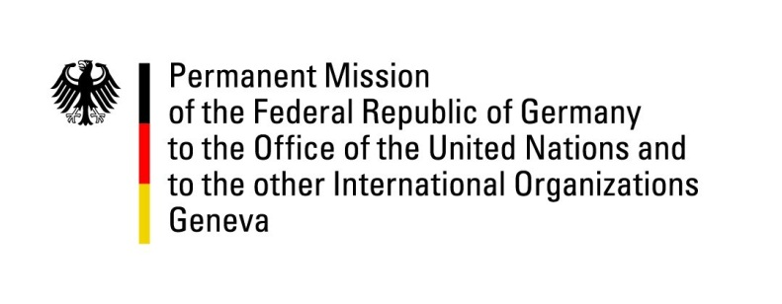

United Nations Human Rights Council
27th Session of the UPR Working Group

Geneva, 3 May 2017

---
German recommendations
to
Finland

Mr President,

Germany welcomes the delegation of Finland to the third cycle of the UPR.

Germany appreciates the positive steps taken with respect to the recommendations made during the previous UPR in 2012 and Finland’s long-term, committed engagement for the protection of human rights at national level and in international fora, such as the Human Rights Council and the Organization for Security and Co-operation in Europe.

In that regard, the ratification of the “Council of Europe Convention on preventing and combating violence against women and domestic violence” and the “Convention on the Rights of Persons with Disabilities + its Optional Protocol” are particularly positive developments.

Germany offers the following recommendation to Finland:

- Implement the “Council of Europe Convention on preventing and combating violence against women and domestic violence” within the shortest possible delay in order to provide improved protection and assistance to women and children that have become victims of violence.

I thank you, Mr. President.

